Eğitim ve Dil Dergisi
Journal of Education and Language
ISSN:aaaa-aaaa
Makale Türü ♦ Künye Bilgisi

[Tüm Metin için: Helvetica 14 p. Türkçe] Aaaaa Aaaaaaa Aaaaa ve Aaaaaaa için Aaaaa Aaaaaaa ile Aaaaa Aaaaaaa∗
Yazar Adı Soyadı [10 p.]

Özet [8 p.]
Aaaaaaa aaaaaaaa aaaaa. [8 p]

Anahtar Sözcükler: Aaaaaaa, aaaaaaaa, aaaaa, aaaaaa [8 p]
[Helvetica 14 p. İngilizce] Aaaaa Aaaaaaa Aaaaa ard Aaaaaaa for Aaaaa Aaaaaaa with Aaaaa Aaaaaaa
Abstract [8p.]

Aaaaaaa aaaaaaaa aaaaa. [8 p]

Key Words: Aaaaaaa, aaaaaaaa, aaaaa, aaaaaa [8 p]

1. GİRİŞ [11 p] Başlıklandırmalar makalenin amacına uygun olarak düzenlenebilir.
[9 p Tüm Metin için.] Aaaa aaaaaaaaa aa aaaaaaa aaaaa aaaaaa aaaaaa aaaa aaaaaa aaa. Aaaa aaaaaaaaa aa aaaaaaa aaaaa aaaaaa aaaaaa aaaa aaaaaa aaa. Aaaa aaaaaaaaa aa aaaaaaa aaaaa aaaaaa aaaaaa aaaa aaaaaa aaa. Aaaa aaaaaaaaa aa aaaaaaa aaaaa aaaaaa aaaaaa aaaa aaaaaa aaa. Aaaa aaaaaaaaa aa aaaaaaa aaaaa aaaaaa aaaaaa aaaa aaaaaa aaa. Aaaa aaaaaaaaa aa aaaaaaa aaaaa aaaaaa aaaaaa aaaa aaaaaa aaa. [6 nk Kaynakça dışında tüm metin için geçerlidir.]
Aaaa aaaaaaaaa aa aaaaaaa aaaaa aaaaaa aaaaaa aaaa aaaaaa aaa. Aaaa aaaaaaaaa aa aaaaaaa aaaaa aaaaaa aaaaaa aaaa aaaaaa aaa. Aaaa aaaaaaaaa aa aaaaaaa aaaaa aaaaaa aaaaaa aaaa aaaaaa aaa. Aaaa aaaaaaaaa aa aaaaaaa aaaaa aaaaaa aaaaaa aaaa aaaaaa aaa. Aaaa aaaaaaaaa aa aaaaaaa aaaaa aaaaaa aaaaaa aaaa aaaaaa aaa.
1.1. Amaç [11 p]
Aaaa aaaaaaaaa aa aaaaaaa aaaaa aaaaaa aaaaaa aaaa aaaaaa aaa. Aaaa aaaaaaaaa aa aaaaaaa aaaaa aaaaaa aaaaaa aaaa aaaaaa aaa.

1.2. Önem [11 p]
Aaaa aaaaaaaaa aa aaaaaaa aaaaa aaaaaa aaaaaa aaaa aaaaaa aaa. Aaaa aaaaaaaaa aa aaaaaaa aaaaa aaaaaa aaaaaa aaaa aaaaaa aaa.

1.3. Sınırlılıklar [11 p]
Aaaa aaaaaaaaa aa aaaaaaa aaaaa aaaaaa aaaaaa aaaa aaaaaa aaa. Aaaa aaaaaaaaa aa aaaaaaa aaaaa aaaaaa aaaaaa aaaa aaaaaa aaa.

2.YÖNTEM [11 p]
Aaaa aaaaaaaaa aa aaaaaaa aaaaa aaaaaa aaaaaa aaaa aaaaaa aaa. Aaaa aaaaaaaaa aa aaaaaaa aaaaa aaaaaa aaaaaa aaaa aaaaaa aaa.

Tablo, şekil ve grafiklere aşağıda gösterildiği biçimde metin içerisinde yer verilmelidir.

Tablo 4. Aaaaaaa aaaa aaaaaaa. [9 p]
Aaaaa aaaaa | Aaaaa aaaa aa aaaaaa |  |  |  | Aaaaaaa aaaaa
 | Aaa | Aaa |  | Aaaa | Aaa | Aaaaa | Aaaa
Aaaaa aaaa | Aaaaa | Aaaa | Aaaa |  | Aaa | Aaaa | Aa
Aaaa aa | Aaaa | Aaa | Aaaa |  | Aaaaa | Aaa | Aaaa
Aaa aaaaaa | Aaa | Aaaaa | Aaa |  | Aaaaaa | Aaaaa | Aaa
Aaa aaaa | Aaaa | Aa | Aaaaa |  | Aaa | Aaa | Aaaaa
Aaaa aaaaaa | Aaaaa | Aaaaa | Aaaa |  | Aaaaa | Aaaa | Aa

Şekil 2. Aaaaaaa aaaa aaaaaaa. [9 p]

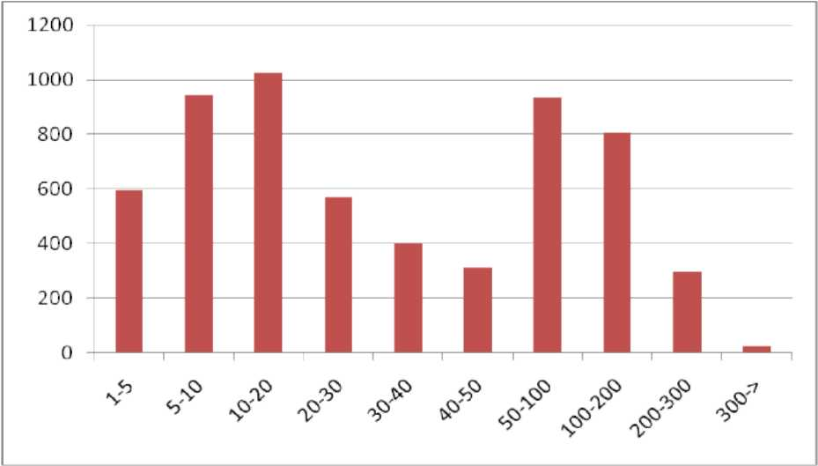
Grafik 1. Aaaaaaa aaaa aaaaaaa. [9 p]

Kaynak Gösterimi
Kaynak gösterimleri aşağıdaki örnekler gibi yapılmalıdır. Olmayan biçimleri için APA 6 kılavuzu kullanılmalıdır. Kaynaklar arasında 3 nk boşluk verilmelidir.
Ulusal/Uluslararası Makaleler
Aaaaa, A., Aaaaa, A. ve Aaaaa, A., (1998). Aaaaaa aaaaaa aaaa aaaaa aaaaa. Dergi Adı. Sayı. Volume. Sayfa Aralığı.
Ulusal/Uluslararası Bildiriler

Aaaaa, A., Aaaaa, A. ve Aaaaa, A., (1998). Aaaaaa aaaaaa aaaa aaaaa aaaaa. Bildiri Kitabının Adı. Konferans Adı. Sayfa Aralığı. 1137–1143. Bildiri Yeri.
Ulusal/Uluslararası Kitap
Aaaaa, A., Aaaaa, A. ve Aaaaa, A., (1998). Aaaaaa aaaaaa aaaa aaaaa aaaaa. Yayın Evi. Basım Yeri.
- Kitap İçinde Bölüm
Aaaaa, A., (1998). Aaaaaa aaaaaa aaaa aaaaa aaaaa içinde Aaaaa, A. ve Aaaaa, A. ed.. Kitap Adı. Yayın Evi. Sayfa Aralığı. Basım Yeri.
- Editörlü Kitaplar
Aaaaa, A. ve Aaaaa, A., ed. (1998). Aaaaaa aaaaaa aaaa aaaaa aaaaa. Yayın Evi. Basım Yeri.
Makaleler
Aaaaa, A., (1998). Aaaaaa aaaaaa aaaa aaaaa aaaaa. Dergi Adı. Sayı. Volume. Sayfa Aralığı.
Bilimsel Raporlar
Aaaaa, A., Aaaaa, A. ve Aaaaa, A., (1998). Aaaaaa aaaaaa aaaa aaaaa aaaaa. Rapor Türü. Raporun Sunulduğu Kurum. Rapor Numarası. Hazırlandığı Yer.
Tezler
Aaaaa, A., (1998). Aaaaaa aaaaaa aaaa aaaaa aaaaa. Tez türü/durumu. Enstitü Adı. Yayın Yeri.
Güncel Yazılar
Aaaaa, A., (1998). Aaaaaa aaaaaa aaaa aaaaa aaaaa. Yayın Adı. Sayı. Volume. Sayfa Aralığı.
Web Adresleri
Aaaaa, A., (1998). Aaaaaa aaaaaa aaaa aaaaa aaaaa. http://www.aaaaaaa/aaaa/aaaa.html. (20.05.2004).

∗ Kurum Adı, e-posta, ORCID ID: [7 p] Diğer tüm dipnotlar için de [7 p]

